**Klamath River Basin 2020 World Fish Migration Day Story Map**

**Project Information Request Form**

*A collaborative effort of the*

*California Fish Passage Forum, Klamath River Renewal Corporation, and their partners.*

**Project Name: Sharber-Peckham Fish Passage Restoration Project**

**Project Location Coordinates: 40.89719400 : -123.56276600**

**Project Description:**

This project replaced an undersized culvert which has created a migration barrier to anadromous fish species on Sharber/Peckham Creek.  This project provided access to 1.2 miles of upstream spawning and rearing habitat for threatened Southern Oregon/Northern California Coasts (SONCC) coho salmon (*Oncorhynchus kisutch*), Upper Klamath-Trinity Rivers Chinook salmon (*Oncorhynchus tshawytscha*) and Klamath Mountains Province Steelhead trout (*Oncorhynchus mykiss*. This project was one of the highest priority recovery actions listed for the Lower Trinity population unit in NMFS SONCC Coho Recovery Plan, and implementation of this project has increased population and species viability, helping to recover coho salmon in the Klamath River basin.

Post project monitoring conducted by the Forest Service in 2017 had identified 740 juvenile coho rearing above the culvert replacement site, demonstrating the success of this project.

**Lead Implementing Organization:**​ Northwest CA Resource Conservation & Development Council

**Project Partners: CA Fish Passage Forum, USFS, NMFS, CDFW**

**Attach/upload photos and/or links to videos, articles etc.**

<https://www.5counties.org/sharber-peckham.htm> - video

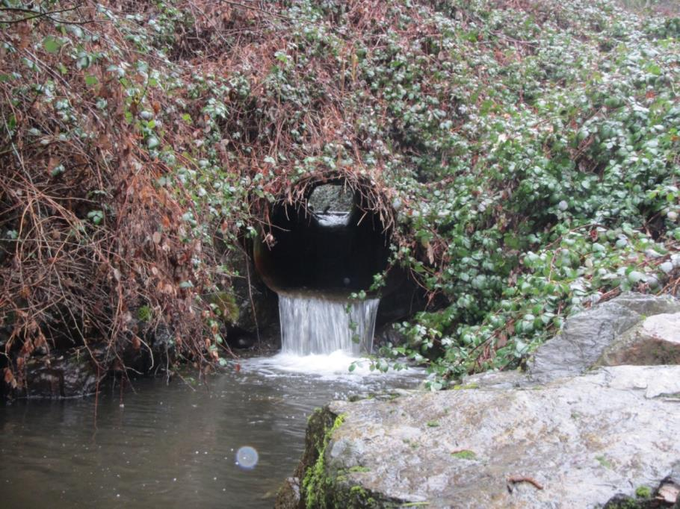

Pre project Outlet Conditions

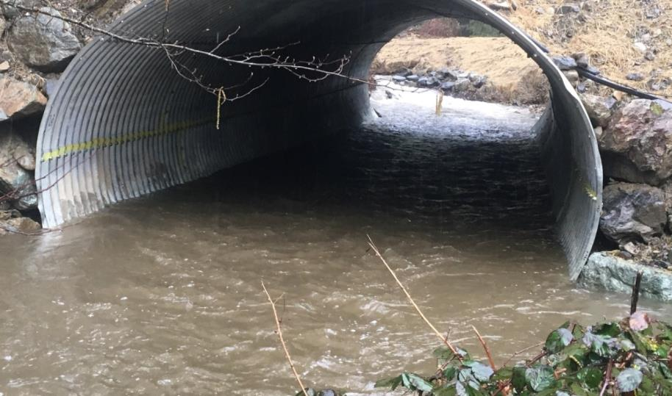

Post Project outlet Conditions

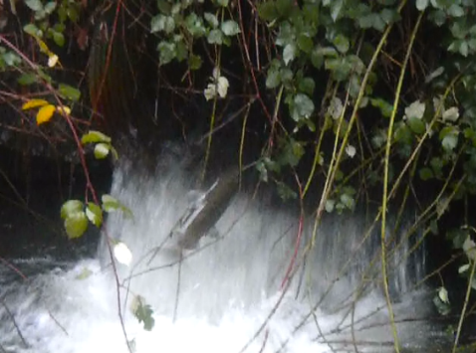

Adult salmon trying to access the creek pre project

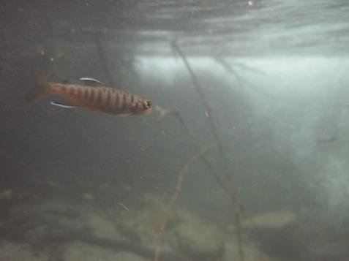

Juvenile coho found in habitat upstream of the culvert post project

**Quick Fun Fact:**

(optional)