**Klamath River Basin 2020 World Fish Migration Day Story Map**

**Project Information Request Form**

*A collaborative effort of the*

*California Fish Passage Forum, Klamath River Renewal Corporation, and their partners.*

**Project Name:** O’Neil Creek Off Channel Habitat Enhancement

**Project Location Coordinates:** Decimal Degrees 41.811, -123.115

**Project Description:** O’Neil Creek is a small tributary to the Klamath River (River Mile 137) that provides habitat for SONCC coho salmon, and other salmonids and cold water fishes. This and other tributaries in this stretch of the Klamath River, between Scott River and Seiad Creek, currently do not provide much high quality habitat for spawning or rearing salmonids; however being the migration corridor that all fish traveling between the upper and lower basin must navigate, it is critical to improve and optimize conditions in this area for salmonids. The project was designed to create about 7,000 square feet (0.15 acres) of riparian wetland habitat, improve fish passage to this habitat, and provide complex, high quality off-channel rearing habitat for coho salmon.

The goal of this, and other off-channel fish habitat enhancement projects on the Klamath National Forest, is to improve salmonid rearing, as well as migration to high quality habitats throughout the Middle Klamath River. This project is small but it provides cold water refugia and rearing opportunities that are critically needed in this section of the river for successful salmonid migration and fulfillment of life history in the Klamath Basin. These restoration sites are monitored for fish use and after-care needs following high flow events. Monitoring by Karuk Fisheries and others have demonstrated coho salmon use, and improved growth, in these constructed off-channel habitats.

**Lead Implementing Organization:**​ Klamath National Forest, Happy Camp Oak Knoll Ranger District

**Project Partners:** Mid Klamath Watershed Council, Karuk Tribe; Caltrans mitigation program provided funding for implementation and monitoring)

**Attach/upload photos and/or links to videos, articles etc.**

**Before**

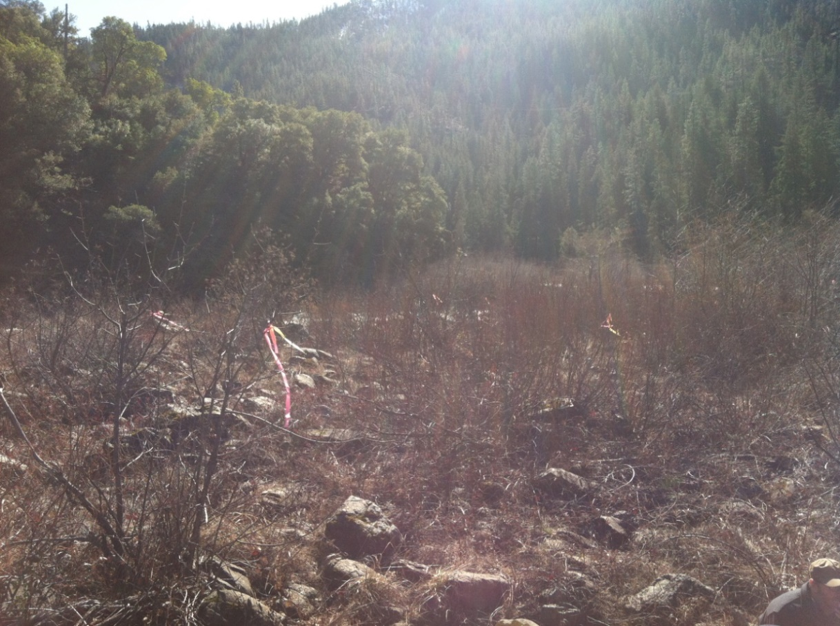

**After**

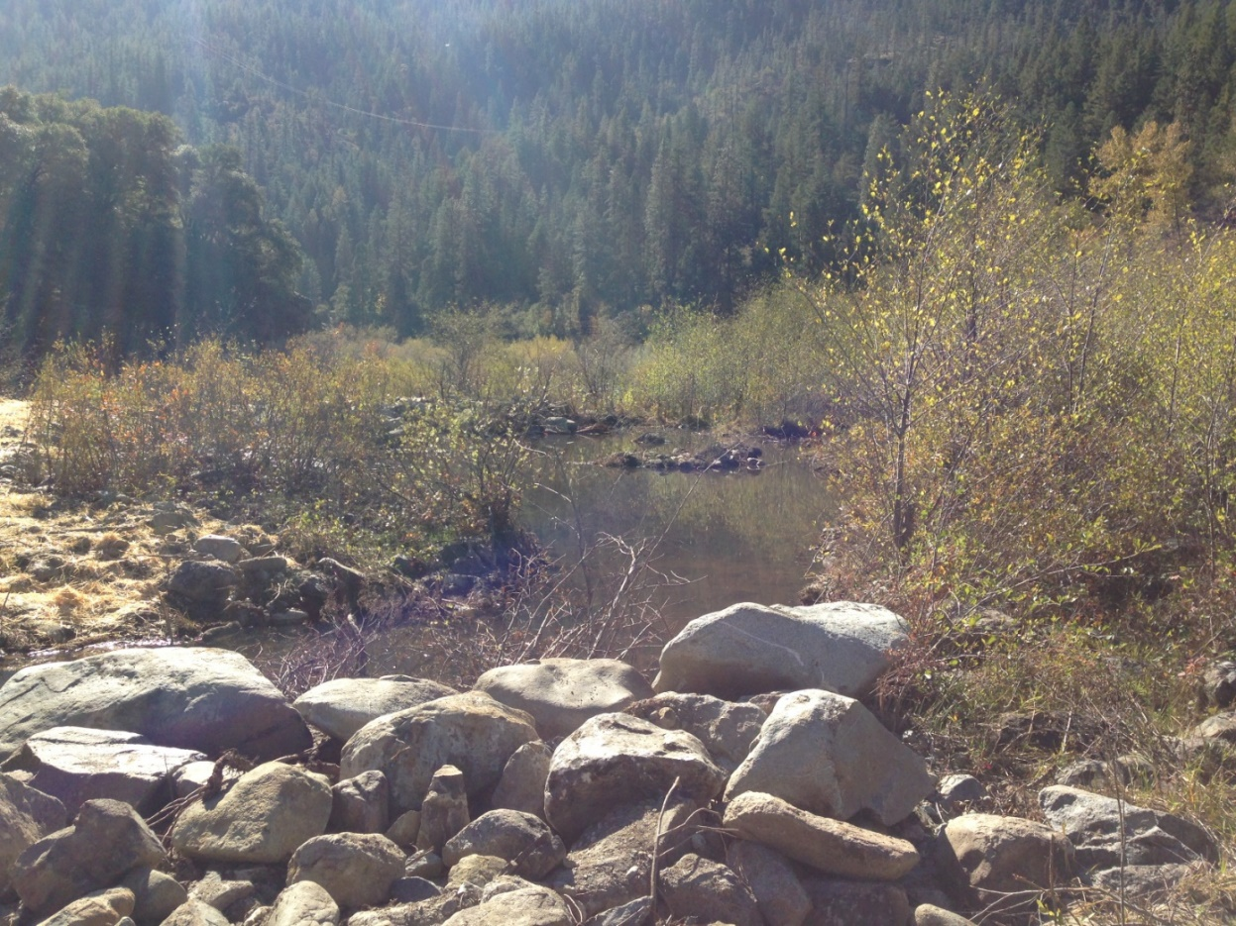

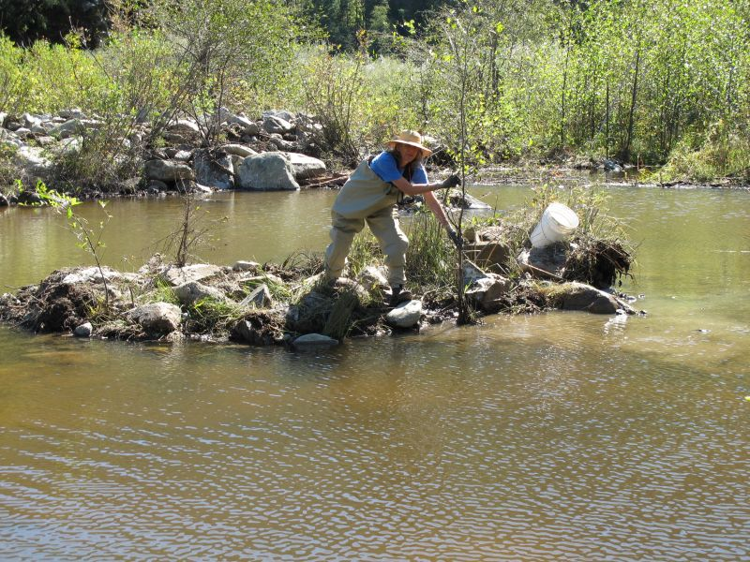

**Quick Fun Fact:**

(optional)