**Klamath River Basin 2020 World Fish Migration Day Story Map**

**Project Information Request Form**

*A collaborative effort of the*

*California Fish Passage Forum, Klamath River Renewal Corporation, and their partners.*

**Project Name:** Grenada Irrigation District Dam Removal Project

**Project Location Coordinates:** Lat Long (Decimal: 41.61338, ‐122.49461)

**Project Description:**

The Shasta River has long been recognized as the single most important spawning tributary in the Klamath Basin. Counts of Fall Chinook returning to the Shasta (even after substantial basin-wide declines) were as high as 82,000 in 1931. While in 1992 they had dropped to a little over 500, they have since rebounded to as many as 13,000. Coho and steelhead have not yet experienced as significant an increase, but both are present.

The project removed the Grenada Irrigation District’s (GID) diversion dam and replaced it with a roughened channel meeting CDFG/NOAA fish passage criteria. This project has allowed for year round access to 23 miles of cold habitat on the Shasta River, an important Klamath River tributary. This project was also coupled with the Huseman Ditch Relocation Project which also provides habitat enhancement by allowing 11.9 cfs to remain in the Shasta River for an additional 4.7 miles through prime spawning and rearing reaches of the Shasta River. The project significantly benefits Southern Oregon Northern California Coho (SONCC) salmon (Threatened under the ESA and CESA), steelhead and lamprey and has provided for year-round access to over 23 miles of excellent cold water habitats. Chinook salmon has also benefited from improved access to prime spawning and rearing reaches.

Juvenile fish passage monitoring efforts using PIT tag technology have shown that juvenile fish been detected have been detected passing through the former dam site. Of the 91 steelhead tagged and released downstream of GID, 17 were later detected at the PIT tag antennas upstream. The juvenile steelhead that were known to pass upstream through the GID site included individuals of a range of sizes and most individuals migrated from the release location to the antenna station in less than 5 days.

**Lead Implementing Organization:**​ Grenada Irrigation District

**Project Partners: NOAA Restoration Center, CA Department of Fish and Wildlife, USFWS, NFWF, Wildlife Conservation Board**

**Attach/upload photos and/or links to videos, articles etc.**

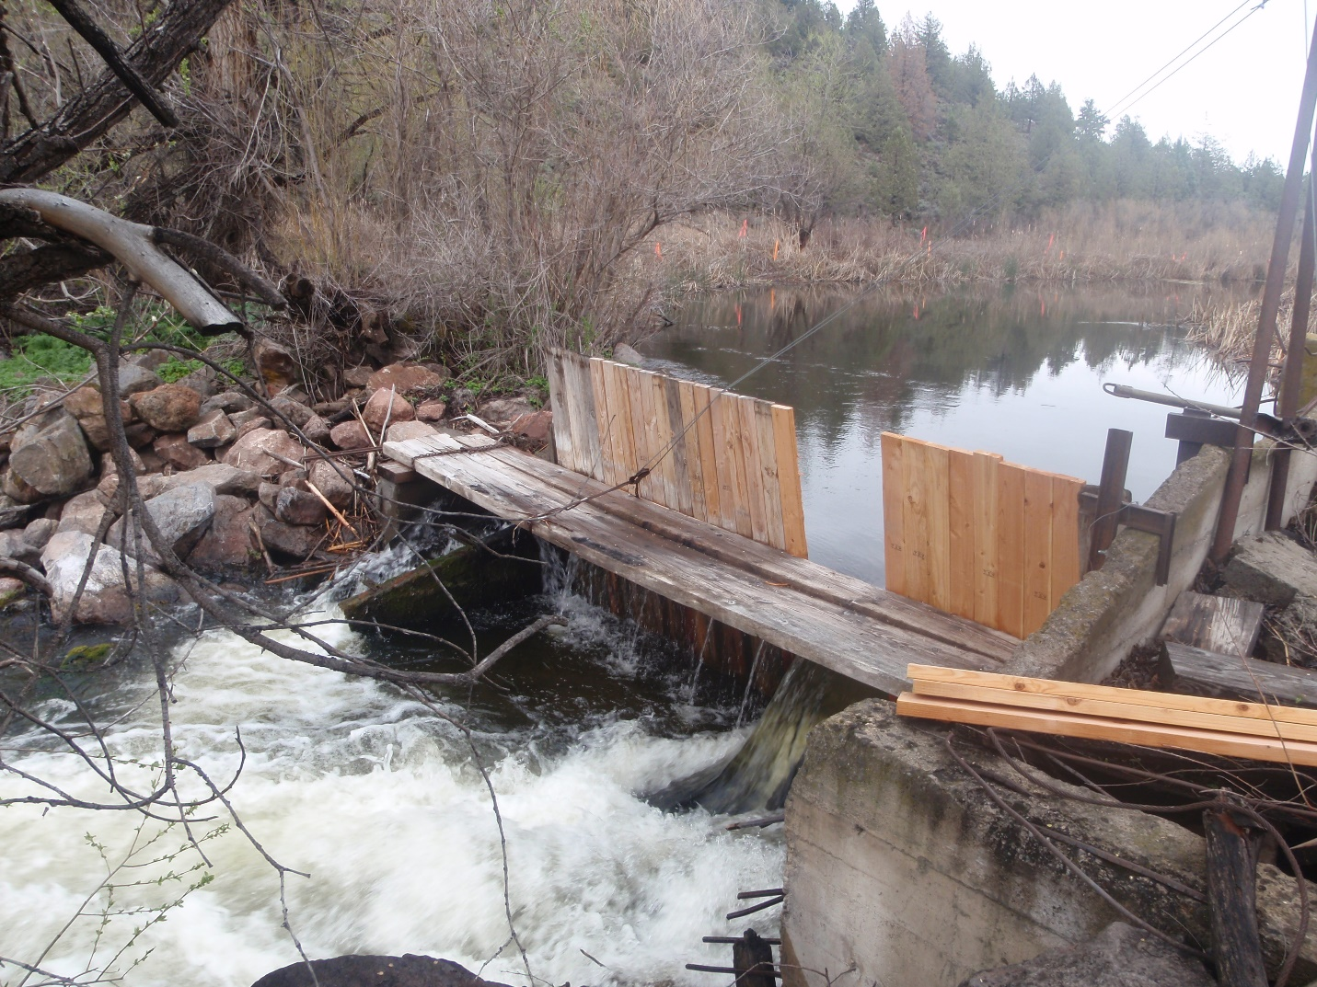

GID Dam looking up stream pre project



**GID dam looking downstream post project**

**Quick Fun Fact:**

(optional)