**Klamath River Basin 2020 World Fish Migration Day Story Map**

**Project Information Request Form**

*A collaborative effort of the*

*California Fish Passage Forum, Klamath River Renewal Corporation, and their partners.*

**Project Name:** Fort Goff Bridge

**Project Location Coordinates:** Decimal Degrees 41.865, -123.258

**Project Description:** The project improved fish passage near the mouth of Fort Goff Creek where a 15 foot diameter culvert conveyed flows under State Hwy 96. The high flow velocities through this culvert restricted Steelhead trout access to approximately 4 miles of suitable habitat and Coho salmon and Chinook salmon access to approximately 1.6 miles of suitable habitat in Fort Goff Creek. The need to remedy the fish passage barrier at Fort Goff Creek is listed in the National Marine Fishery Service’s Southern Oregon/Northern California Coast Coho Recovery Plan, and the California Department of Fish and Wildlife’s Recovery Strategy for Coho Salmon.

After the project was completed, large numbers of Chinook salmon were observed spawning in Fort Goff Creek upstream of Hwy 96 during the 2014 fall Chinook redd and carcass survey, and in subsequent years. In addition to the 1.6 miles of Coho salmon and Chinook salmon and 4 miles of Steelhead trout spawning habitat now accessible, the project also increased the amount of accessible thermal refugia habitat in this stretch of the river.

**Lead Implementing Organization:**​ Caltrans

**Project Partners:** USFWS, CDFW, NMFS, Karuk Tribe, National Fish and Wildlife Foundation, and Forest Service

**Attach/upload photos and/or links to videos, articles etc.**

**Pre Project**

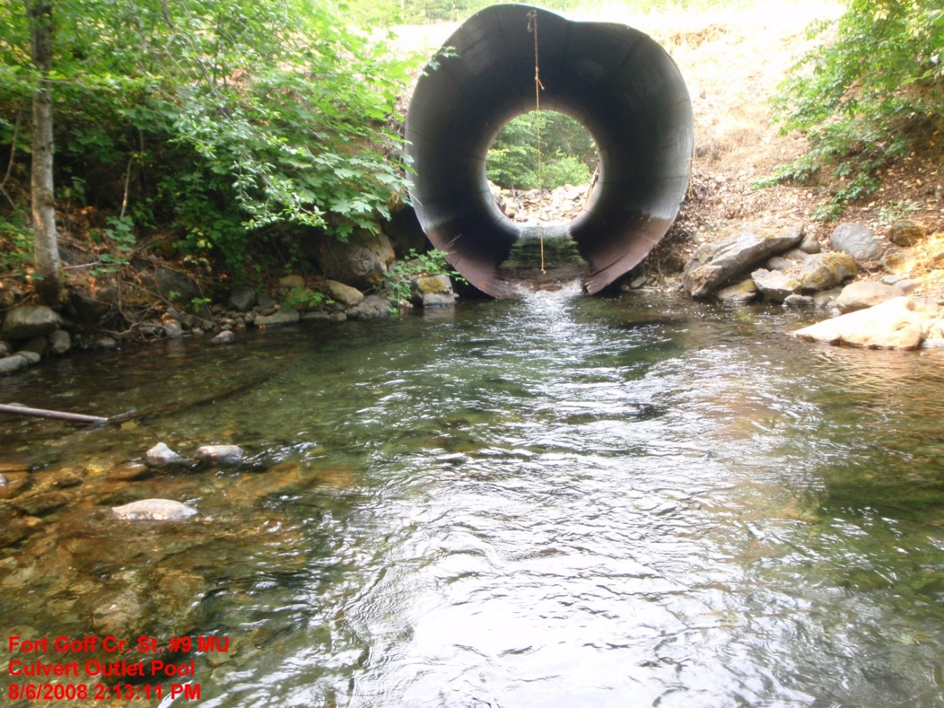

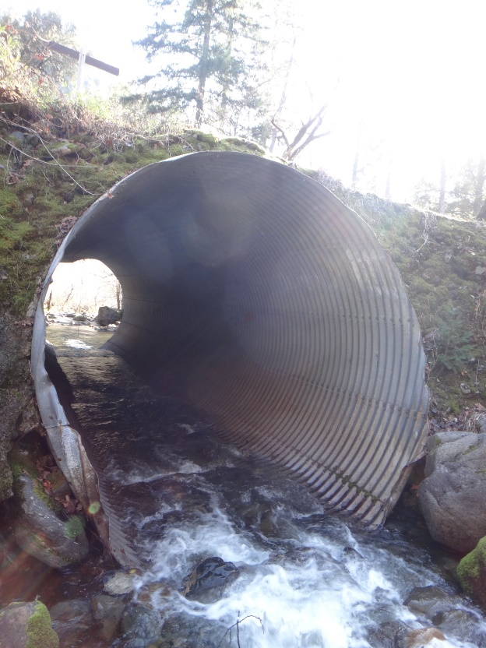

**Post Project**

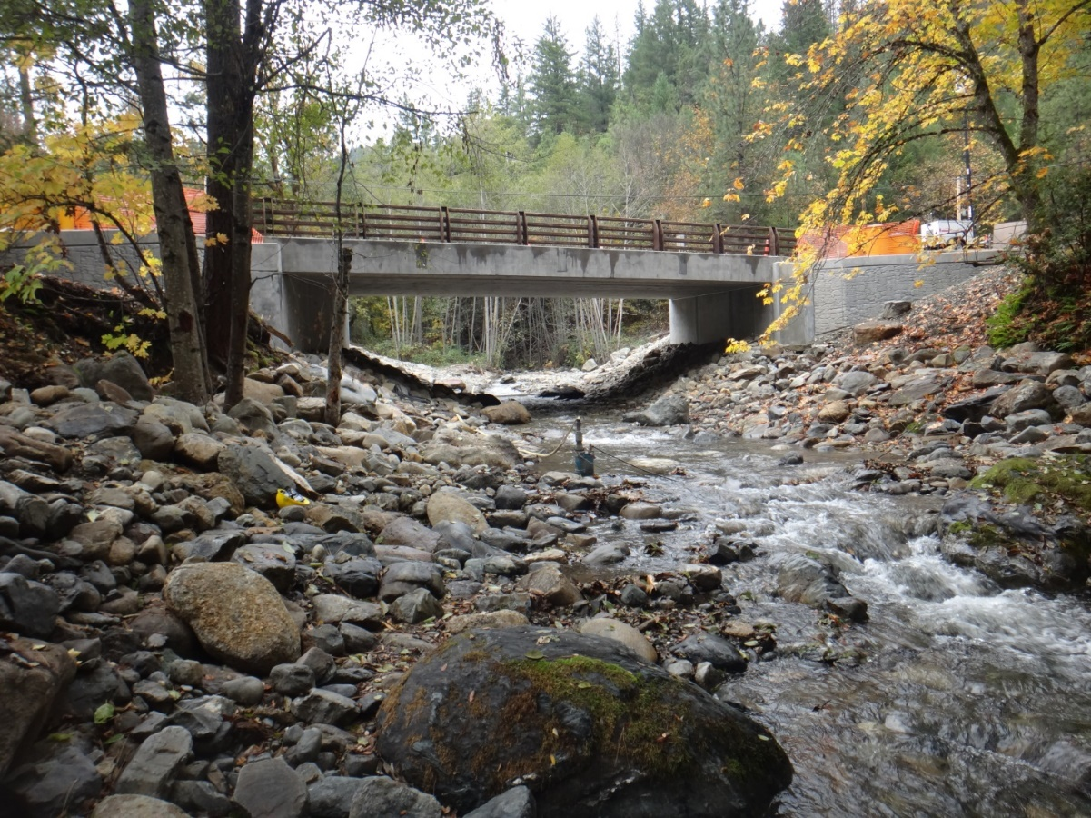

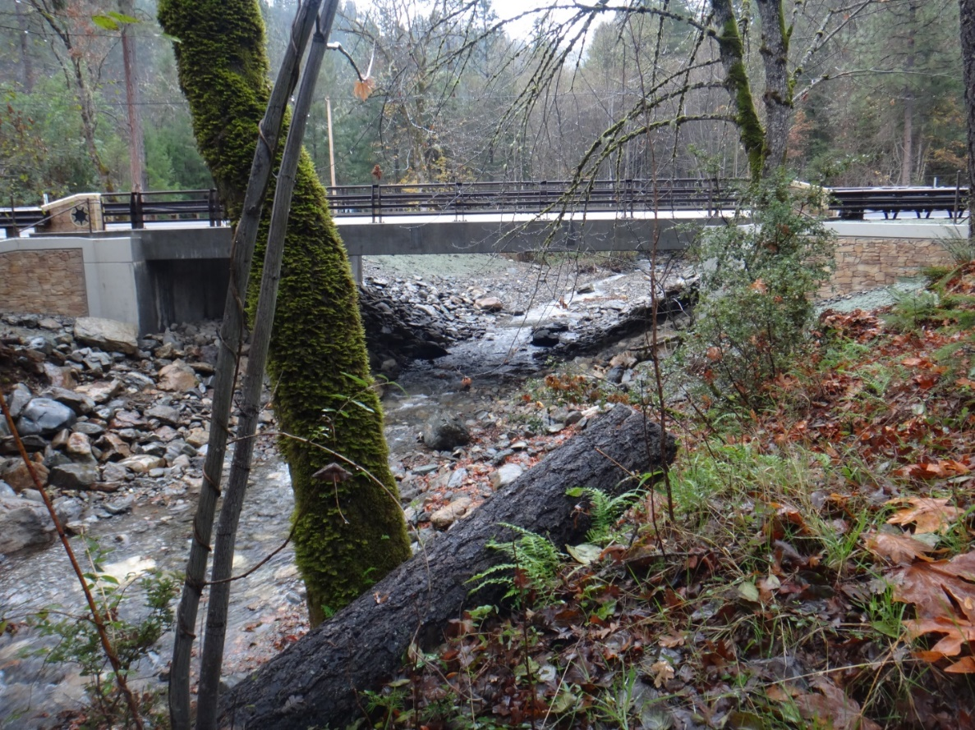

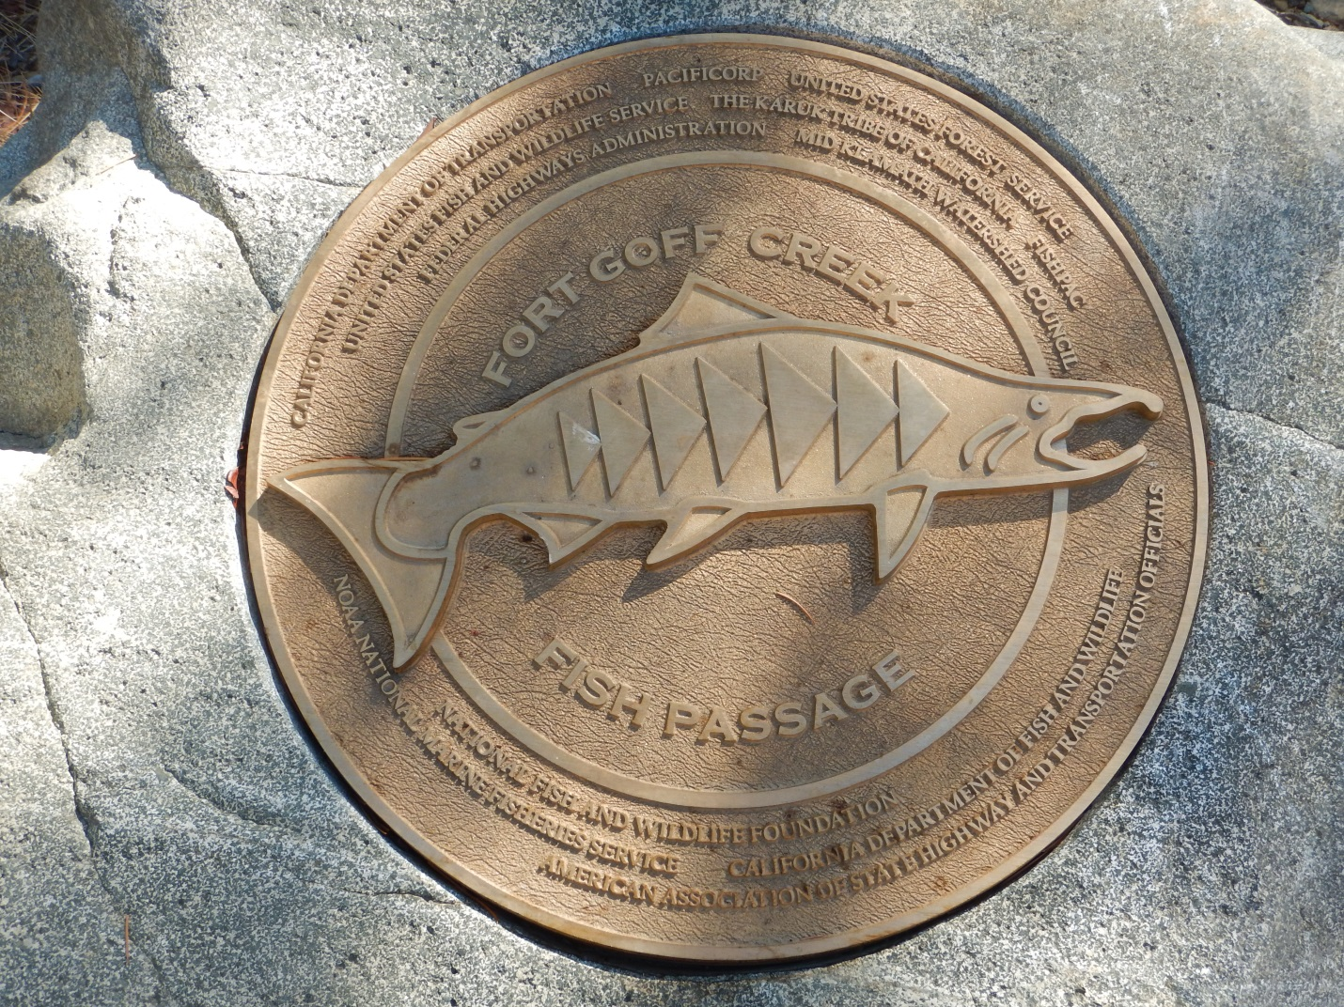

**Quick Fun Fact:**

(optional)