**Evans Ranch Diversion Photos**

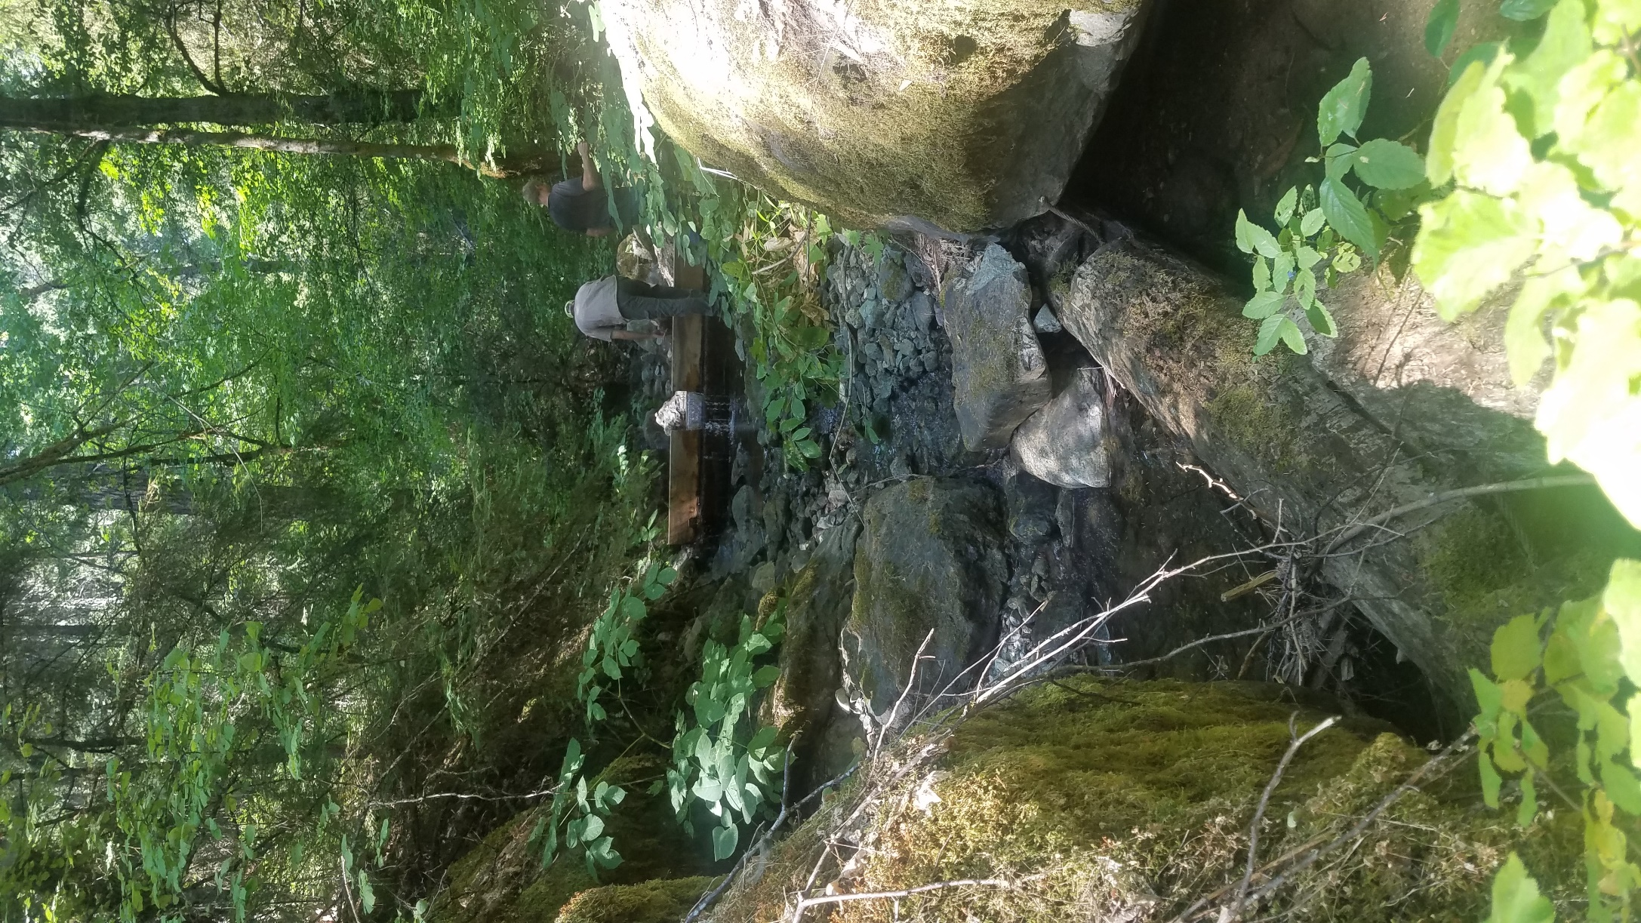

Figure 1: Evans Ranch Diversion with the 18" concrete structure with additional 6-12" flashboard riser. Also note the old CCC habitat structure built just downstream of the diversion. Photo taken during full diversion in summer.

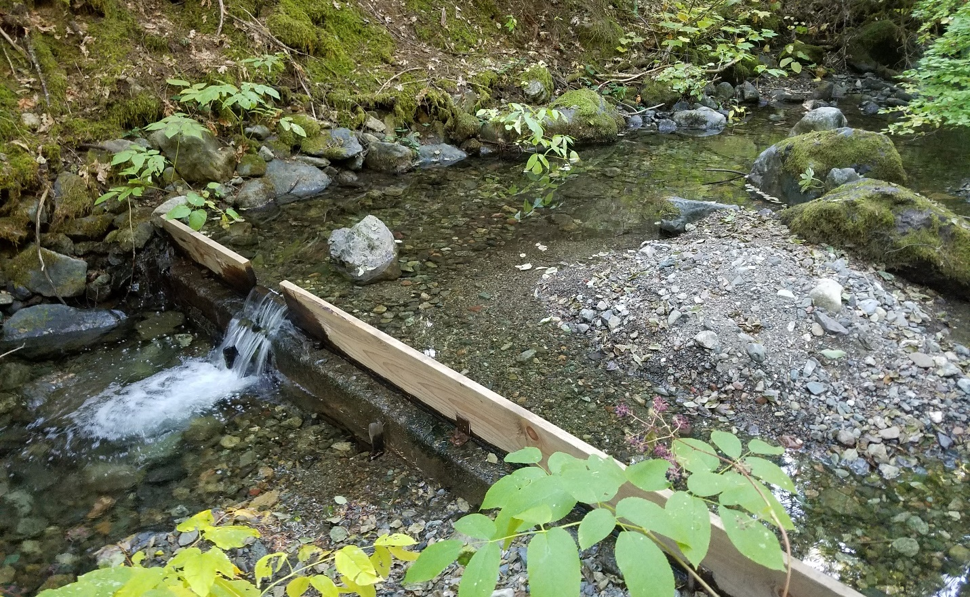

Fish Screen

Figure 2: Evans Ranch Diversion on West Tule Creek looking upstream (during fall, diversion active).

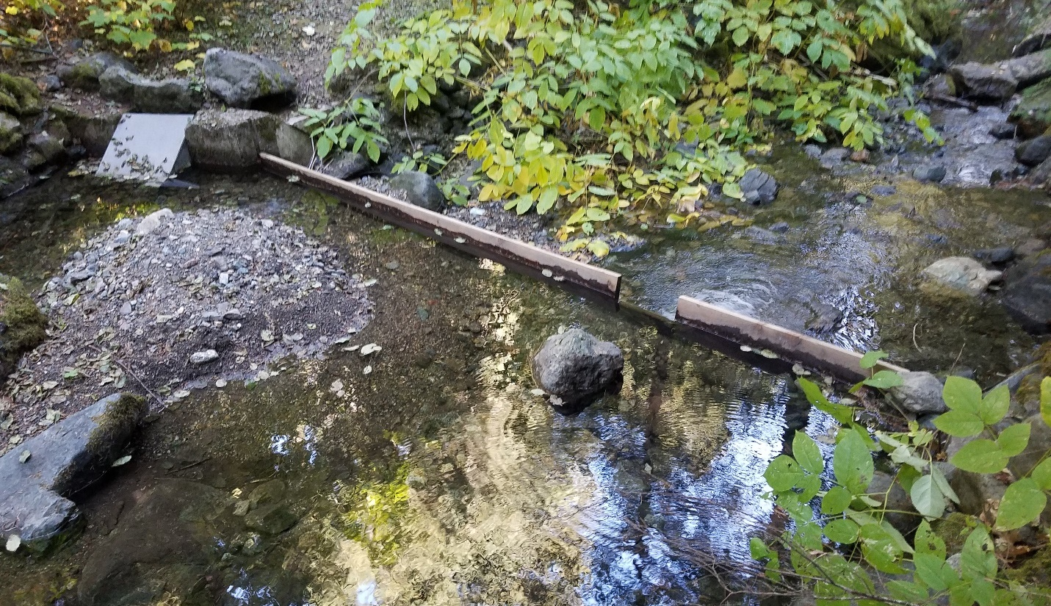

Fish Screen

Figure 3: Evans Ranch Diversion and fish screen looking downstream (during fall, diversion active).

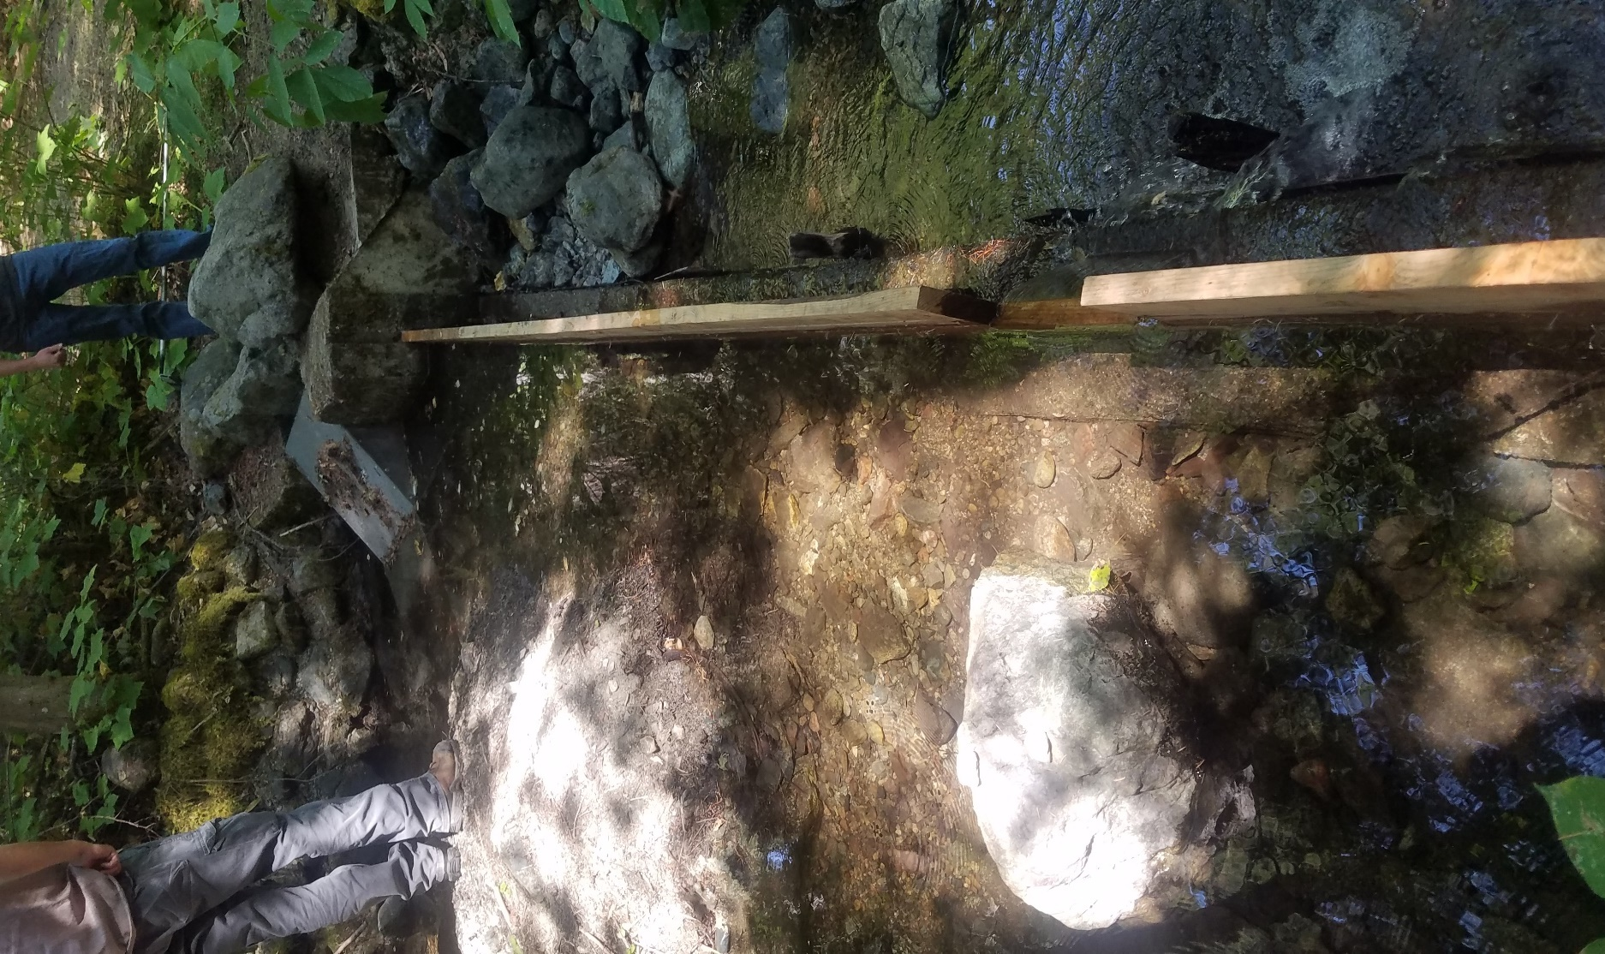

Figure 4: Evans Ranch Diversion and screen, side angle (during summer, diversion active).

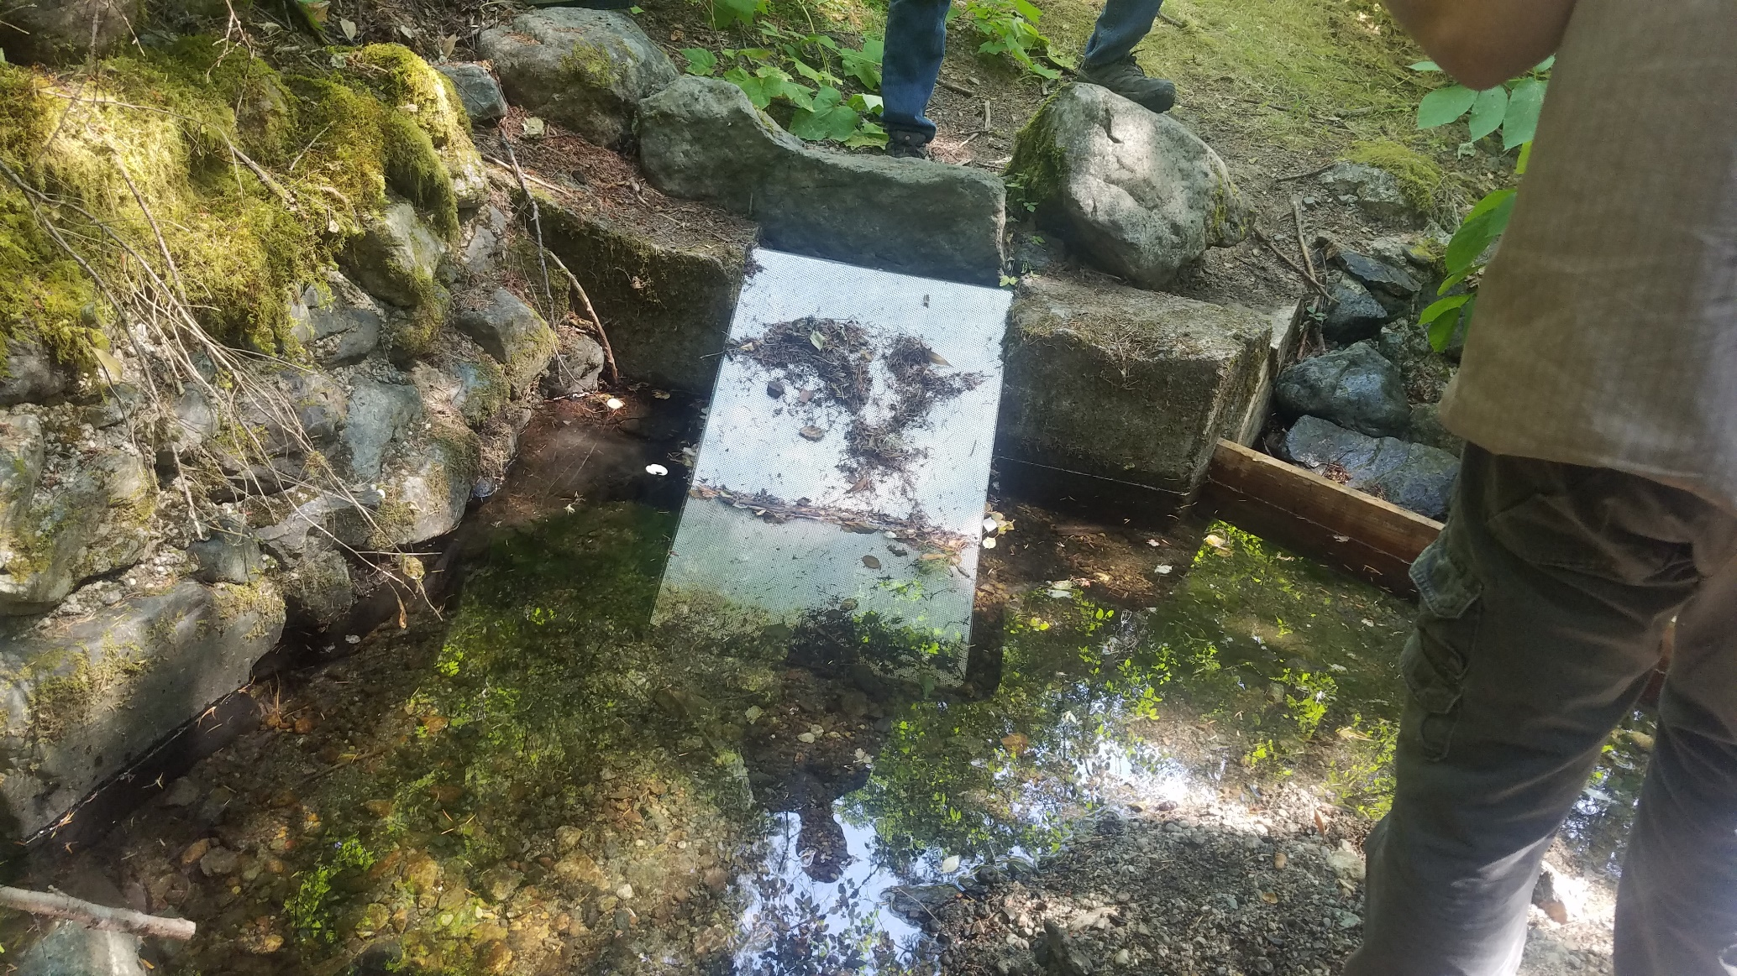

Fish Screen gap

Figure 5: Evans Ranch Diversion screen. Note the large gap in the screen where fish can be entrained during high flows.

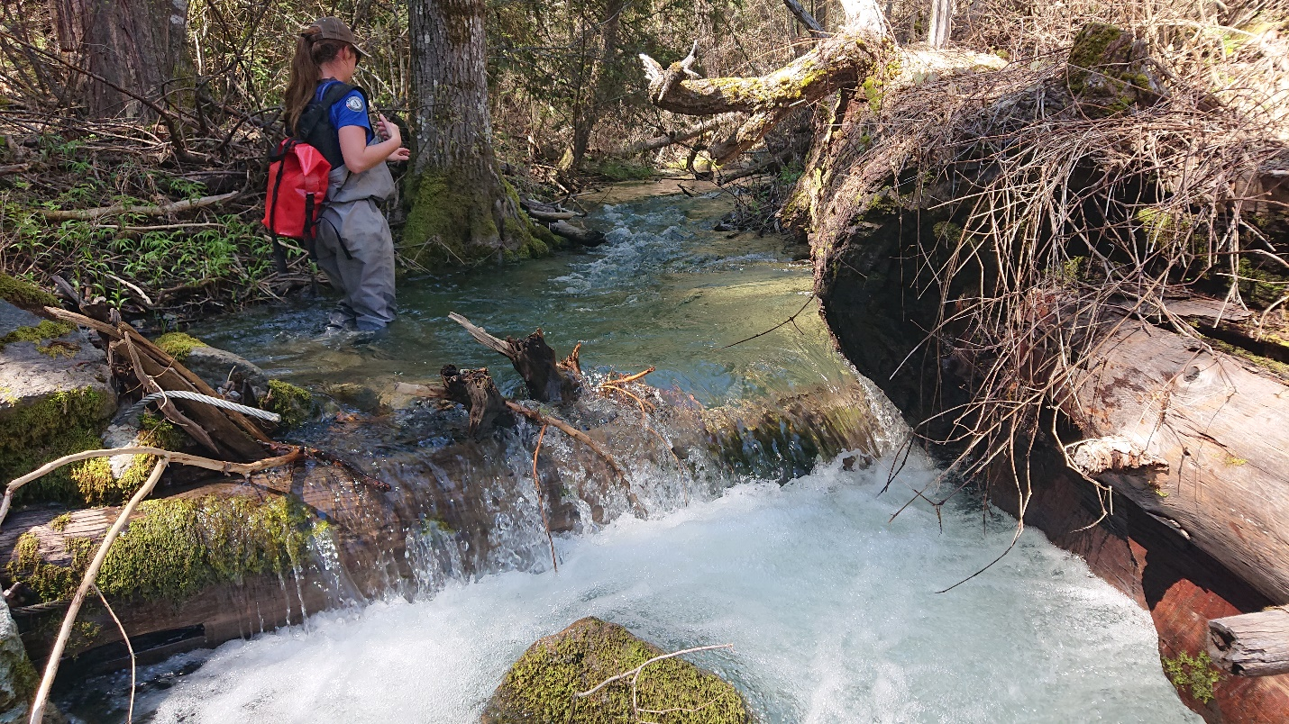

Figure 6: Fish habitat structures like this are installed on West Tule Creek both downstream and upstream of Evans Ranch Diversion (this photo is located downstream of the diversion during spring).

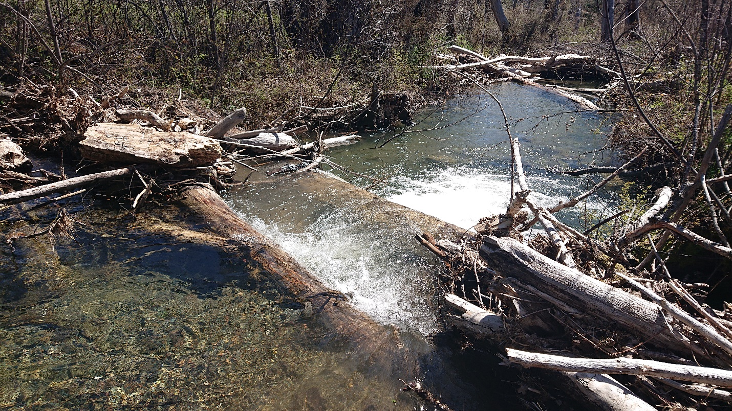

Figure 7: West Tule Creek naturally recruited wood (during spring).